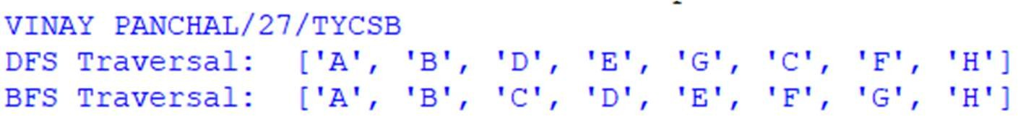

print("VINAY PANCHAL/27/TYCSB")

from collections import deque,defaultdict class Graph:

def init (self): self.graph=defaultdict(list)

def add_edge(self,u,v):

#For undirected graph self.graph[u].append(v) self.graph[v].append(u)

def bfs(self,start):

visited=set() queue=deque([start]) traversal=[]

while queue: node=queue.popleft() if node not in visited:

visited.add(node) traversal.append(node)

for neighbor in self.graph[node]: queue.append(neighbor)

return traversal

def dfs_iterative(self,start): visited=set() stack=[start] traversal=[]

while stack:

node=stack.pop()

if node not in visited: visited.add(node) traversal.append(node)

for neighbor in reversed(self.graph[node]): stack.append(neighbor)

return traversal

g=Graph() edges=[

('A','B'),('A','C'),

('B','D'),('B','E'),

('C','F'),('E','G'), ('F','H')

]

#ADDing edges for u,v in edges:

g.add_edge(u,v) start_node='A'

print("DFS Traversal: ",g.dfs_iterative(start_node)) print("BFS Traversal: ",g.bfs(start_node))

# Output:

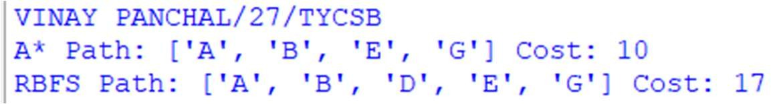

print("VINAY PANCHAL/27/TYCSB")

import heapq

def a_star(graph,h,start,goal):

open_list=[] heapq.heappush(open_list,(h[start],0,start,[start])) visited=set()

while open_list: f,g,node,path=heapq.heappop(open_list) if node==goal:

return path,g visited.add(node)

for neighbor,cost in graph[node]:

if neighbor not in visited:

g_new=g+cost f_new=g_new+h[neighbor]

heapq.heappush(open_list,(f_new,g_new,neighbor,path+[neighbor])) return None,float('inf')

def rbfs(graph,h,start,goal):

def rbfs_helper(node,path,g,f_limit):

if node==goal:

return path,g successors=[]

for neighbor,cost in graph[node]:

if neighbor not in path:

g_new=g+cost f=max(g_new+h[neighbor],f_limit)

successors.append((f,neighbor,g_new,path+[neighbor])) if not successors:

return None,float('inf') successors.sort()

while successors:

best=successors[0]

alternative=successors[1][0] if len(successors)>1 else float('inf') result,f_new=rbfs_helper(best[1],best[3],best[2],min(f_limit,alternative)) if result is not None:

return result,f_new successors[0]=(f_new,best[1],best[2],best[3]) successors.sort()

return None,float('inf')

return rbfs_helper(start,[start],0,float('inf')) graph={

'A':[('B',5),('C',10)],

'B':[('A',5),('D',4),('E',3)],

'C':[('A',10),('G',2)],

'D':[('B',4),('E',6)],

'E':[('B',3,),('D',6),('G',2)], 'G':[('C',2),('E',2)]

}

heuristic={ 'A':7,

'B':6,

'C':4,

'D':3,

'E':2,

'G':0

}

start='A' goal='G' #Run A*

a_path,a_cost=a_star(graph,heuristic,start,goal) print("A*Path:",a_path,"Cost",a_cost)

#Run RBFS

rbfs_path,rbfs_cost=rbfs(graph,heuristic,start,goal) print("RBFS Path:",rbfs_path,"Cost:",rbfs_cost)

# Output:

**Code:**

from sklearn.datasets import load_iris

# Practical – 3 Decision Tree Learning

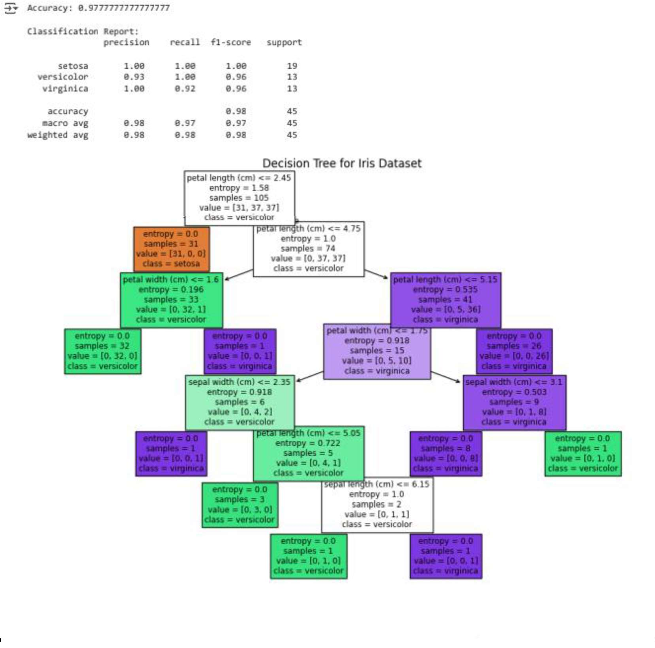

from sklearn.model_selection import train_test_split from sklearn.tree import DecisionTreeClassifier,plot_tree

from sklearn.metrics import accuracy_score,classification_report import matplotlib.pyplot as plt

#load the iris dataset iris = load_iris()

X = iris.data y = iris.target

feature_names = iris.feature_names target_names = iris.target_names #split into train and test sets

X_train, X_test, y_train, y_test = train_test_split(X, y, test_size=0.3, random_state=42) #craete and train the decision tree classifier

elf = DecisionTreeClassifier(criterion='entropy', random_state=42) elf.fit(X_train,y_train)

#make predictions

y_pred = elf.predict(X_test) #evaluate accuracy

accuracy = accuracy_score(y_test, y_pred) print("Accuracy",accuracy)

print("\nClassification Report",classification_report(y_test, y_pred, target_names=target_names)) #Plot the decision tree

plt.figure(figsize=(12,8)) plot_tree(elf,feature_names=feature_names,class_names=target_names,filled=True) plt.title('Decision Tree for Classifier')

plt.show()

# Output:

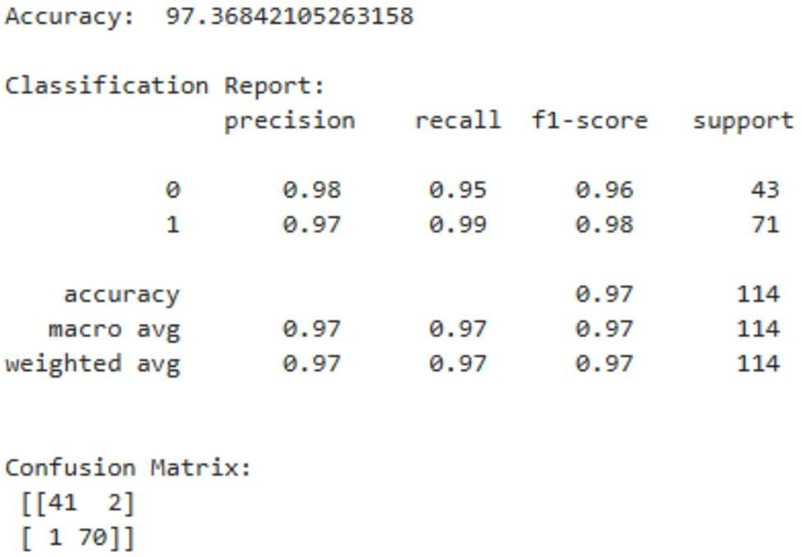

**Code:**

from sklearn.datasets import load_breast_cancer

from sklearn.model_selection import train_test_split,GridSearchCV from sklearn.svm import SVC

from sklearn.preprocessing import StandardScaler

from sklearn.metrics import classification_report,accuracy_score,confusion_matrix

#load binary classification dataset data=load_breast_cancer()

X=data.data y=data.target#Labels:0=Malignant,1=Benign #Normalized features scalar=StandardScaler() X_scaled=scalar.fit_transform(X)

#Split into training and testing data X_train,X_test,y_train,y_test=train_test_split(X_scaled,y,test_size=0.2,random_state=42) #Build SVM model

svm_model=SVC(kernel='rbf',C=1.0, gamma='scale') svm_model.fit(X_train,y_train)

#MAke Prediction y_pred=svm_model.predict(X_test) #Evaluate Performance

print("Accuracy:",accuracy_score(y_test,y_pred)*100) print("\nClassifcation Report:\n",classification_report(y_test,y_pred)) print("Confusion Matrix:\n",confusion_matrix(y_test,y_pred)) #Hyperparameter tuning using GridSearchCV

param_grid={ 'C':[0.1,1,10],

'gamma':['scale',0.1,1], 'kernel':['rbf']

}

grid=GridSearchCV(SVC(),param_grid,cv=5) grid.fit(X_train,y_train)

print("\nBest Parameters:",grid.best_params_) print("Best Cross-validation score:",grid.best_score_)

# Output:

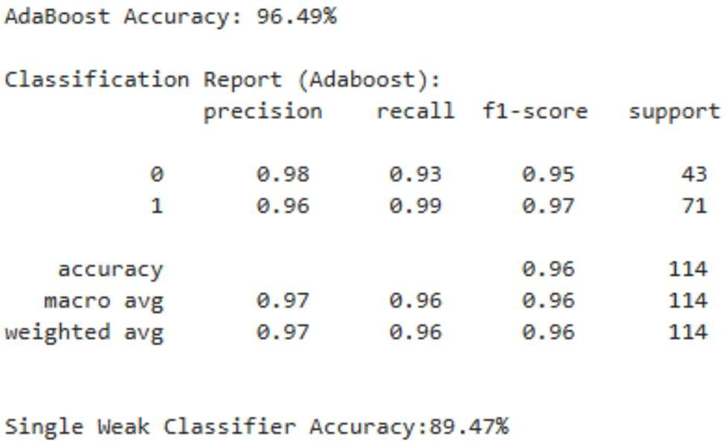

**Code:**

from sklearn.datasets import load_breast_cancer from sklearn.model_selection import train_test_split from sklearn.ensemble import AdaBoostClassifier from sklearn.tree import DecisionTreeClassifier

from sklearn.metrics import accuracy_score,classification_report #Load dataset

data=load_breast_cancer()

X=data.data y=data.target #Train-test split

X_train,X_test,y_train,y_test=train_test_split(X,y,test_size=0.2,random_state=42) #weak classifier:Decision stump(1-level decision tree) weak_classifier=DecisionTreeClassifier(max_depth=5)

#Train Adaboost model with 50 weak classifiers adaboost_model=AdaBoostClassifier(estimator=weak_classifier,n_estimators=50,random_state=42) adaboost_model.fit(X_train,y_train)

#Predict and evaluate y_pred=adaboost_model.predict(X_test) accuracy_ada=accuracy_score(y_test,y_pred) print(f"AdaBoost Accuracy: {accuracy_ada*100:.2f}%")

print("\nClassification_report(AdaBoost):\n ",classification_report(y_test,y_pred)) #compare with a single weak classifier

weak_classifier.fit(X_train,y_train) y_pred_weak=weak_classifier.predict(X_test) accuracy_weak=accuracy_score(y_test,y_pred_weak)

print(f"\nSingle weak classifier Accuracy: {accuracy_weak*100:.2f}%")

# Output:

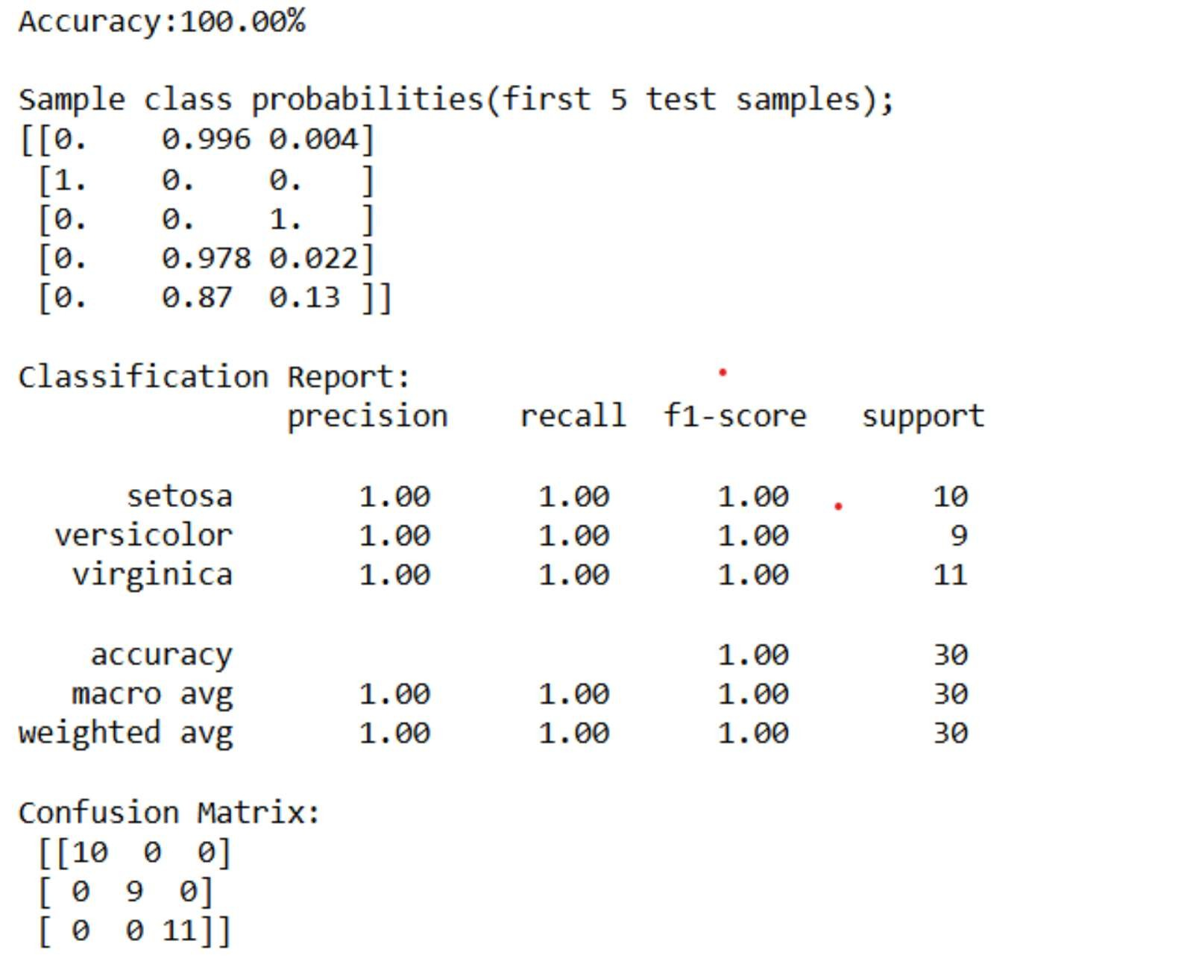

from sklearn.datasets import load_iris

from sklearn.model_selection import train_test_split from sklearn.naive_bayes import GaussianNB

from sklearn.metrics import accuracy_score,classification_report,confusion_matrix import numpy as np

#load output data=load_iris() X=data.data y=data.target

class_names=data.target_names #Split into train test

X_train,X_test,y_train,y_test=train_test_split(X,y,test_size=0.2,random_state=42) #train NaiveBayes classifier

model=GaussianNB() model.fit(X_train,y_train) #predict y_pred=model.predict(X_test) #Evaluate Accuracy

accuracy=accuracy_score(y_test,y_pred) print(f"Accuracy: {accuracy*100:.2f}%\n") #class probabilities probs=model.predict_proba(X_test)

print("Sample class probabilities(first 5test samples):") print(np.round(probs[:5],3))

#detailed evaluation

print("\nClassifier Report:\n",classification_report(y_test,y_pred,target_names=class_names)) print("Confusion matrix:\n",confusion_matrix(y_test,y_pred))

# Output:

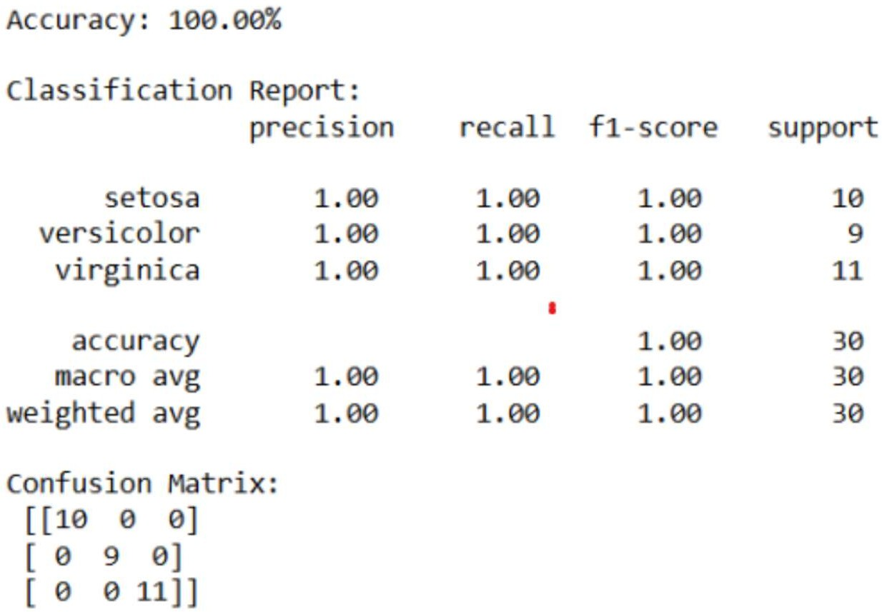

from sklearn.datasets import load_iris

from sklearn.model_selection import train_test_split from sklearn.preprocessing import StandardScaler from sklearn.neighbors import KNeighborsClassifier

from sklearn.metrics import accuracy_score, confusion_matrix, classification_report

#load dataset data = load_iris()

X = data.data y = data.target

class_names = data.target_names #Train-test split

X_train, X_test, y_train, y_test = train_test_split(X, y, test_size=0.2, random_state=42) #feature scaling

scaler = StandardScaler()

X_train = scaler.fit_transform(X_train) X_test = scaler.transform(X_test) #intialize KNN classifier

knn = KNeighborsClassifier(n_neighbors=3) knn.fit(X_train, y_train)

#predict

y_pred = knn.predict(X_test) #evaluate

accuracy = accuracy_score(y_test, y_pred) print(f"Accuracy: {accuracy*100:.2f}%")

print("\nClassification Report:\n", classification_report(y_test, y_pred, target_names=class_names)) print("Confusion Matrix:\n", confusion_matrix(y_test, y_pred))

# Output:

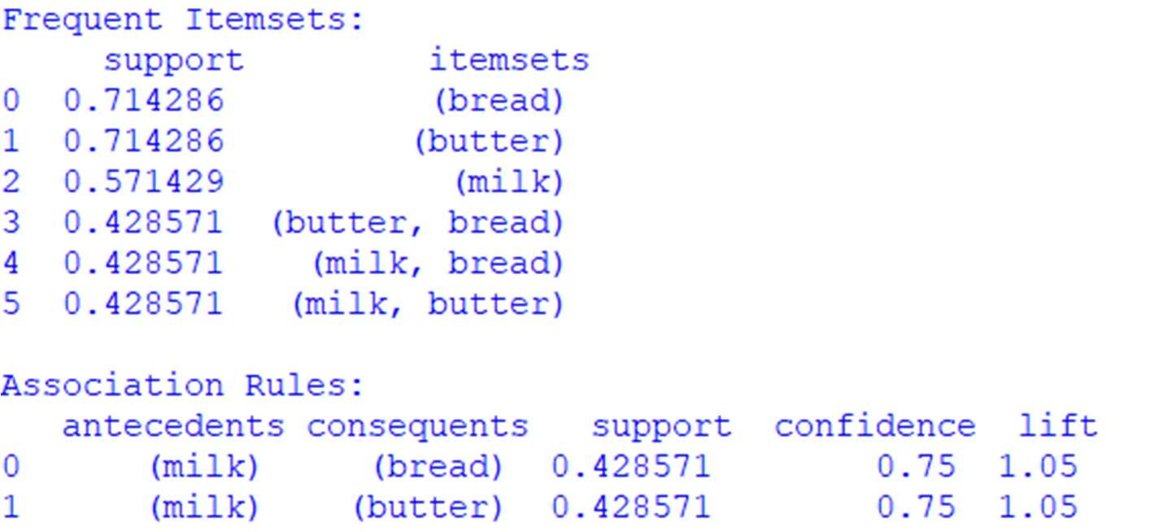

**Code:**

import pandas as p

from mlxtend.frequent_patterns import apriori, association_rules #sample market basket dataset

dataset=[ ['milk','bread','butter'],

['bread','butter'],

['milk','bread'],

['milk','butter'], ['bread'], ['milk','bread','butter'], ['butter']

]

#Convert to one-hot encoded DataFrame

from mlxtend.preprocessing import TransactionEncoder te=TransactionEncoder() te_ary=te.fit(dataset).transform(dataset)

df = p.DataFrame(te_ary, columns=te.columns_) #1.Find frequent itemsets wih min support of 0.3

frequent_itemsets=apriori(df,min_support=0.3,use_colnames=True) #2.generate rule with min confidence of 0.7

rules=association_rules(frequent_itemsets,metric="confidence",min_threshold=0.7) #display results

print("Frequency Itemsets:\n",frequent_itemsets)

print("\nAssociation Rules:\n",rules[['antecedents','consequents','support','confidence','lift']])

**Output:**